Highcliffe School Student Bulletin
Monday 22nd – Friday 26th January 2007 Week A

Thought For The Week:
If you want to feel rich, just count all of the things you have that money can't buy.

School shoes: If any student is not wearing plain black school shoes they will be required to wear black school daps/plimsoles. Therefore if students have wet or broken shoes, have sore feet and need to wear soft shoes they need to report to the Year Office during tutor time. Dap/plimsoles will be lent to the student for the day, all sizes are available. If a student has a medical reason for not wearing plain black school shoes they must produce a Doctor's certificate to their Head of Achievement or Mrs Riley and they will be issued with a uniform card to be carried during the school day.

Lost Property: There are a number of jackets, coats and fleeces in Student Support at the moment, mostly unnamed. Also rather a lot of scarves!! If you have lost anything recently please don't forget to come along and check to see if it has turned up and most importantly KEEP CHECKING. Please make sure that all uniform has your name in it. It is much easier to return clothing if it has your name clearly written on the labels. Thank you. Mrs. Thompson, Student Support Office.

YEAR 8/9 ONLY There will be a mock trial competition meeting on Friday at 1.40pm in HU5. If you can not attend please see Mrs Read as soon as possible.

Environmental group - On Thursday 25th January we have a representative from Christchurch council coming to speak to us about recycling. Anyone is welcome to come along to hear what she has to say - and to share ideas about recycling at Highcliffe. Meet at 1.20pm prompt in Sc6

Italian exchange (October 2007) forms: All year 7 students interested in participating in the Italian exchange trip to Como in October need to ensure that they have the relevant application forms. If not, they can obtain them from Miss Court (ML4). Students wishing to attend the trip now need to return forms as quickly as possible in order to secure a place.

Year 11 Religious Education/Religious Studies revision sessions begin on Thursdays in H7 at 3.30pm. These will run until Easter. Everyone welcome!

YELLOW PAGES: Please bring any 2005/2006 yellow pages to school by Tuesday 23rd January as the Yellow wood company are coming to pick them up. We have lots and lots now but need more to secure our chance of victory! Please give front covers to Miss High in Sc6

CONGRATULATIONS to 10.6 who are officially the most popular tutor group in the school. They collected a massive 436 Christmas card envelopes. Can a representative come to see Miss High to collect your tasty prize!

Art, Art Textiles and Photography Exhibition At Highcliffe Castle: Art, Art Textiles and Photography students from Highcliffe School have been selected to exhibit their work at Highcliffe Castle. The exhibition 'Time and Place' runs from Friday 2nd February - 25th February 11.00am – 4.00pm daily and includes a range of exciting work completed by students in years 7-13.
Please join us for the Private View on Thursday 1st February between 4.30 - 5.30pm at Highcliffe Castle. Thank you for your support.
Ball Games: Please be careful when playing football in the tennis courts. Do not kick the balls too high and hard – remember there is a car park next to the tennis courts. Please respect other peoples’ property.

Bookies Book Club: Wednesday 24th January, 1.45pm in the library. The focus this week will be on Classic Literature.

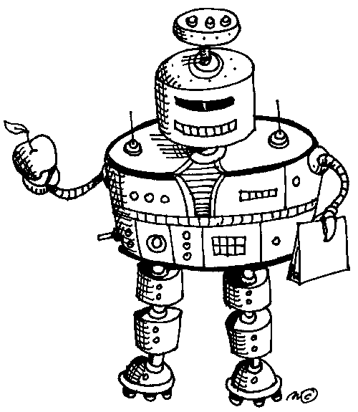
Sorry, but the Library will be closed at lunchtime on Tuesday 23rd January.

ROBOTICS - Mrs Johnson, Sc8 ALL YEARS WELCOME! Robotics will take place on Tuesday after school this week. 3.30pm - 5.00pm A robotic expert (hydralics) will be coming into school on Tuesday 6th February (3.30-5.00pm). If you are interested in taking part in this workshop numbers are limited, see Mrs Johnson Sc8

Fantasy Rugby Competition: Go to http://scrum.fantasyleague.com to enter you team. Do you know more about rugby than Mr Dean? Will Mr Maurice's French sqaud be victorious this 6 nations? To enter the Highcliffe School XV private league you need the pin number 655. Entries to be in before 1st of February, it's FREE to enter. Good luck!

Work is set to begin on the creation of the wildlife area to the side of Da Vinci, see Miss High if you want to get involved in any way

42nd Street Tap Dancers For the Musicals Production: Calling all tap dancers in the school we are looking for a big tap dancing number in this year's production 'Can't Stop the Beat'. It doesn't matter how much you have done there will be easy and hard bits, and you don't need to audition. Please bring your tap shoes to a rehearsal on Wednesday lunchtime in the Performance Hall at 1:45pm.


MUSIC NOTICES:

Tuesday after school: Musical rehearsal for Group A and soloists 3.20 - 5.00pm

Wednesday after school: Musical rehearsal for Group B, C and soloists 3.20 - 4.30pm

Thursday after school: Musical rehearsal for chorus Full Chorus 3.20 - 5.00pm

Saturday: All day rehearsal: 10.00am - some soloists
11.00am - Chorus A and B
12.00pm - Male and Female Chorus
1.00pm - Full Chorus
End 4.00pm

See schedule on Can't Stop the Beat notice board outside Ex2 for full details.
Reminder: All cast members need to take £5 to the Finance Office for their T-shirt.

Coming soon Highcliffe School Young Musician of the Year:
Categories this year include Wind (Woodwind and Brass), Strings, Keyboard (Piano and Electric Keyboard), Drums, Guitar (Electric, Acoustic and Bass) and Voice

The competition is during school on February 12th - 14th with a winner's concert on February 15^{th.} Get practising!

PE NOTICES:
Ski fitness begins next Tuesday and Thursday lunchtimes.
Anyone going on the school ski trip are expected to attend one session per week in gym at lunch, a register will be kept. This will help improve your fitness, and aid the enjoyment of the trip.
You will need to bring your indoor PE kit, trainers. It should last about 20mins from when you arrive.

Basketball leagues
Congratulations to both the Year 7 and 9 basketball teams, who won the Bournemouth schools leagues. The Year 8 team finished runners up and the Year 10/11 team finished 3rd. A truly successful season with 20 games played and only 3 losses!!!!!

Well done to the folowing students who have been selected to represent Bournemouth schools in the forthcoming County Cross Country finals.

Year 7 - Hugh Dathan, Dean Lambert, Charlotte Warner
Year 9 - Josh Harris, Janie Rogers, Alice Curtin, Hannah Vincent
Year 11 - Chris Symons
Year 12 - Jamie Pitcher, Robert Spencer, Eric Thorp

Good Luck!!

The new Football Season Begins next week so why not get along to Football club, just for fun or get in the team!

Results

Year 7 A Team Basketball v Twynham A Team Won 16-14
Year 7 B team Basketball v Twynham B team Won 8-6
Year 8 A team Basketball v Twynham A team Lost 6-22
Year 8 B team Basketball v Twynham B tea Lost 10-12
Year 9 A team Basketball v Twynham A Team Drew 10-10
Year 9 A team Basketball v Arnewood A Team Won 11-10
Year 10/11 A team Basketball v Twynham A Team Lost 11-18
Year 10/11 B team Basketball v Twynham A Team Lost 10-12

Lunchtime movies: Showing this week in the Dance Studio: ‘Cars’, followed by ‘The Incredibles’ – admission free, all welcome!

BUILD YOUR VOCABULARY:
Recently on "Big Brother", Jade Goodie's mother complained that she faced a "dimella". What she meant of course was "dilemma." Find out the following information about this word:

1. What does it mean?
2. Where does the word come from?
3. Give an example of the word in use, which clearly shows the meaning. This could be something from a piece of writing or an example from your speech. As long as the example clearly shows the meaning that's fine.

Bring the following information to Mr. Bryden (by Friday 2nd February at the latest). If he is satisfied that you have got the answer correct, the first person to have done so will get a prize.

BRAIN TEASER:
The answer to last weeks Brainteaser was: If there are 48 dancing legs at the ball then there must be 4 insects (4 × 6 = 24 legs) and 3 spiders (3 × 8 = 24 legs). If this was the answer you gave then look on the plasma screens next week to see if you are our winner!

This weeks Brainteaser is: The numbers in the middle column are related in some way to the numbers in the left and right columns. How are they related?

3 | 42 | 8
5 | 51 | 3
7 | 53 | 5

Answers to be submitted with your name and tutor group in the Brain Teaser box in Ma6 Before Friday 26th January. Good luck.

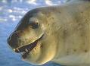
ENLIGHTENING ECO FACT – Everyone in the UK produces half a tonne of waste a year...that’s the same weight as a ferocious Antarctic leopard seal!

